Why is the LED backwords? It is fixed

GND a la patte 3? Non, c Frank qui est cave, c sure que c pas un GND.

Mais le CAP(C303) me pose question? C fine

Will have to make sure? Should be fine

DS_FT231

Weird thing happening on pin 10 and 12

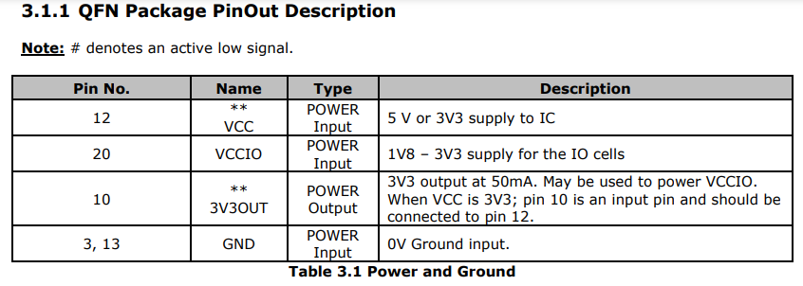

This is no longer used ???

Good boy :

Mobo_V1

Why 2 of them? You could use one of them?

AMS1117-5.0

Me does not like This, with the 5V input that we have :

I will look at the mosfet later